**An alternate way to connect to Oracle2 server using your own local copy of SQL Developer**

**Step1.** Download and Install SQL Developer from <http://www.oracle.com/technetwork/developer-tools/sql-developer/downloads/index.html>

**Step2.** Log into RASS using AUT credentials (<https://distance.aut.ac.nz/login.cgi> ) and Activate RASS.

**Step3.** Run SQL Developer and create new connection on your SQLDeveloper.

e.g.

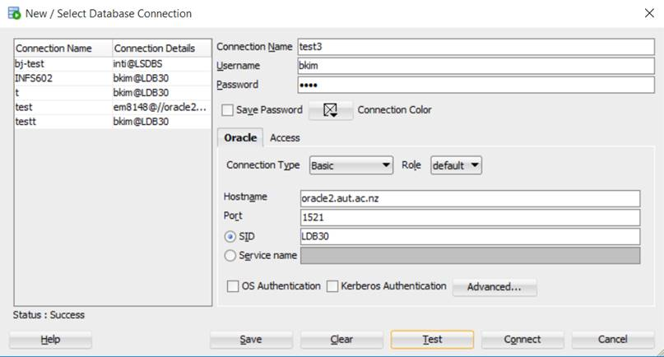

NOTE: You should make RASS connection & activation before you run SQLDeveloper program.